# Create Node-RED Service

|  |  |
| --- | --- |
| **Date** | 09 November 2022 |
| **Team ID** | PNT2022TMID07784 |
| **Project Name** | Project - IoT Based Safety Gadget for  Child Safety Monitoring and Notification |

**Aim**: To create a web application create a Node-RED service.

# Steps followed:

* Navigated to the App creation page

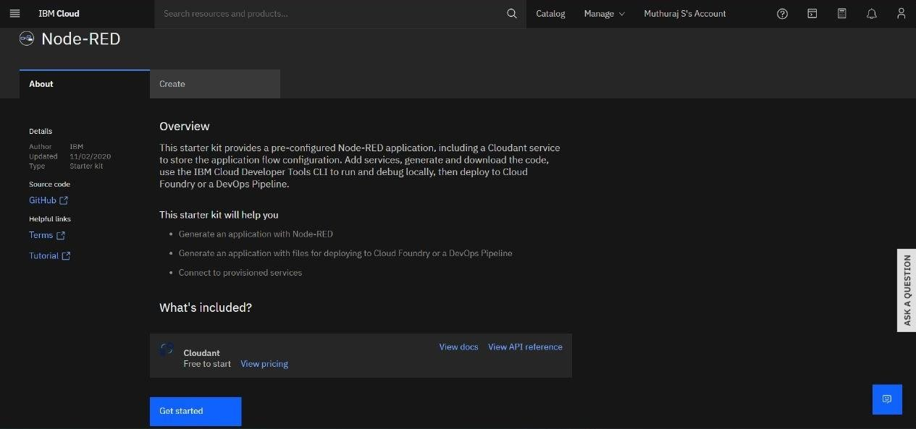

* + Entered project details and clicked on create

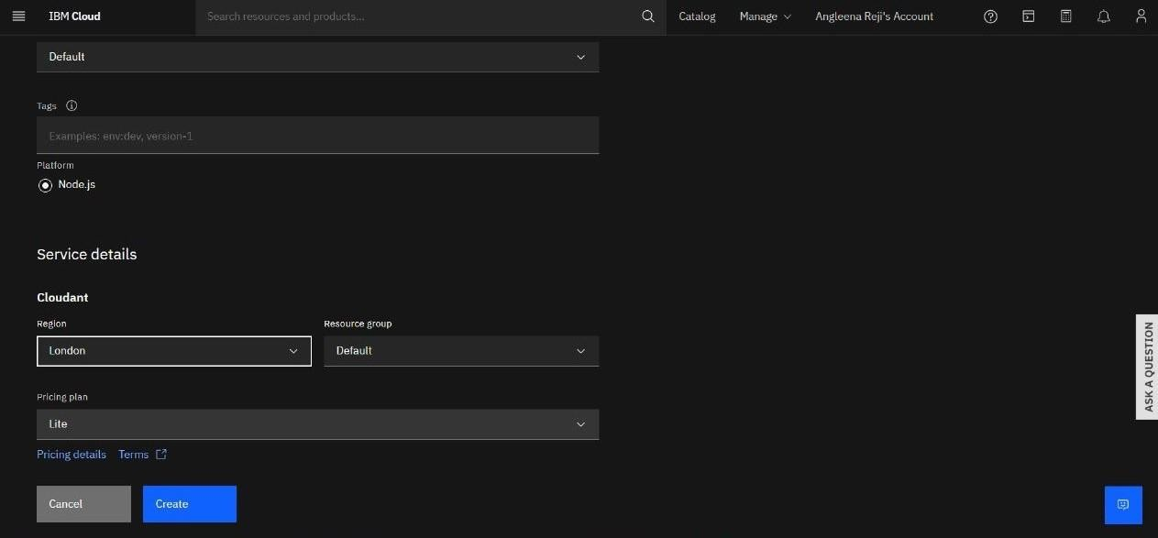

* Clicking on the “Deploy your App” Button

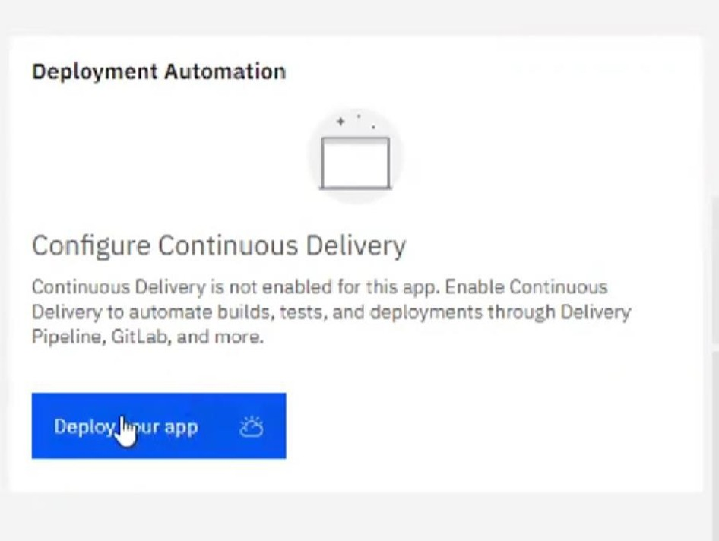

* Setting up the environment and deploying the app

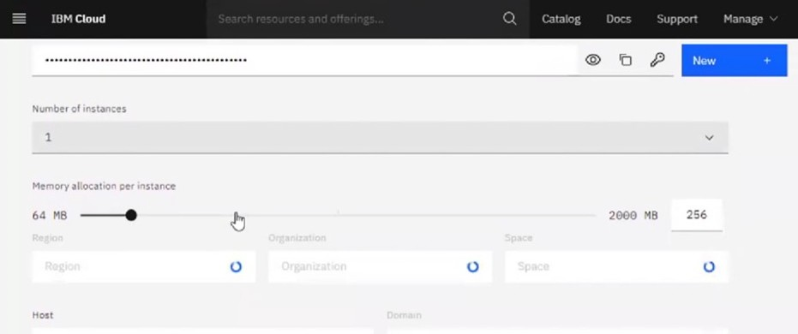

* Successfully deployed the app

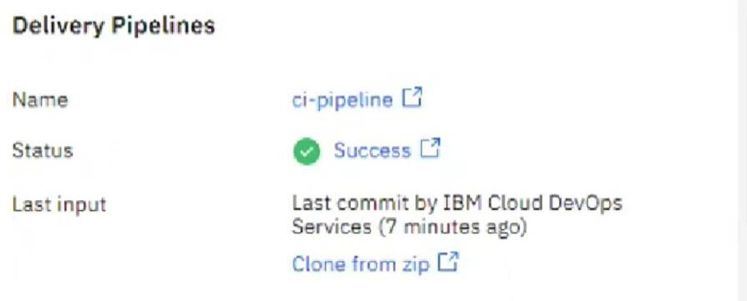

* Dragged and dropped components into the editor

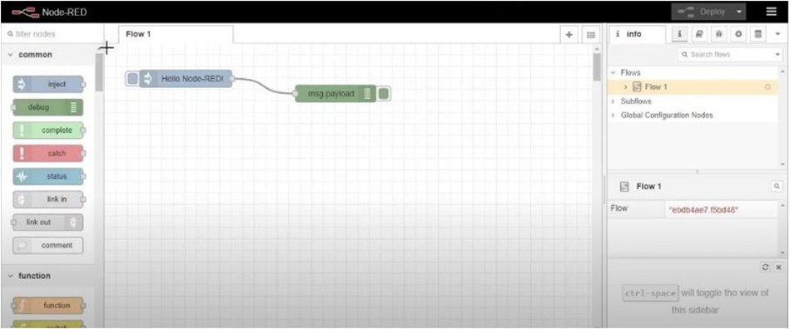

* Editing some values of the properties

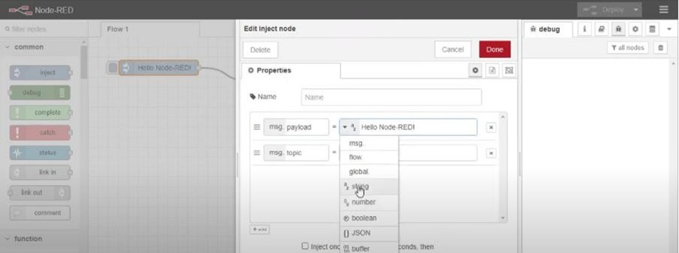

* Successfully deployed the app

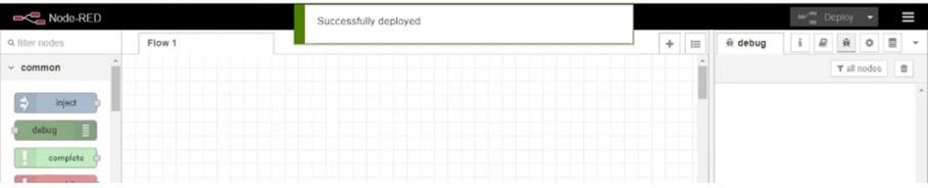

**Result:** Successfully created a NodeRED service on IBM Cloud